Psycho Psummer 50K by Cody Jones
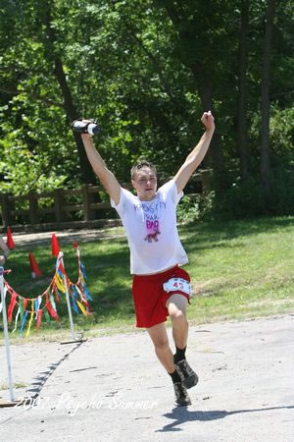

I didn't really know what to expect of myself coming into to Saturday. I was coming off the Leadville marathon the week before, so I had plenty of excuses to dog it. There was really no pressure going in, so I wore the “KC Trail BADASS” shirt, to add a little.

I didn't get much sleep the night before, but I hydrated well (for a big change), so I felt pretty decent at race start. I took it very easy for the first 10 miles or so, just trying to stay cool, eat, and stay hydrated. At the second aid station I caught a little grief about getting "chicked" (something no trail badass should ever do without a fight). At first I let the comment slide off, but then I remembered how incredibly gay it always makes me feel.

At the end of the boy scout loop, I decided to turn up the tempo and see if I couldn't right the situation before the end of the first lap. The legs felt good through the "triangle," so I continued to push and got back where I wanted to be, more or less, coming through the gate at 2:26 and change. I refueled and hydrated as quickly as possible and got back out there.

I felt like I let the pace down a bit, but it was hard to judge with no watch, (or other runners) to gauge by. I looked over my shoulder a lot, but never saw anyone, even in the open stretches. I was getting fairly hot, hungry, tired, and thirsty when I reached the oasis out past the spillway. I made a great refuel and cool down, and took on my first ice at this point. I made it past the next aid station with little effort and high spirits.

Kyle passed me going the other direction on the wooded section of the loop, so I guessed he was about 20 minutes or so ahead of me. This was really my first idea of how I was doing (time-wise) and I was happy with it, since he smoked me by about an hour, in the winter version.

I shuffled-stepped my way back out of there and ran into my brother on my way out. He commented that there were a couple of runners a few minutes ahead that I might be able to catch. With this motivation in mind, I turned up the pace again. Surprisingly, the legs still felt fairly strong.
Coming out of the triangle, I took on my last water (not very cold, Caleb) and pushed on. I really started to heat up by the end with the increased pace and lower water intake. I rolled into a sprint finish in 5:21:48 and 5th place. My best finish of my ultrarunning career by far. I went straight to the recovery tent for an ice-laden cool down and some of Bad Ben's special homemade high carb beverages.

The volunteers were awesome! Great race, despite the heat. A good finish shouldn't hurt my already over-inflated ego. I also like the fact that I was still strong at the end. Bodes well for a longer run, possibly a 100 miler?

