Salt is my Friend by Gabe Bevan
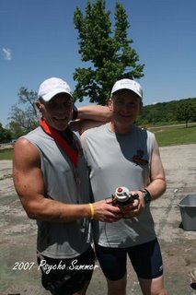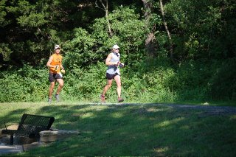
Gabe & Bad Ben Carey and Gabe
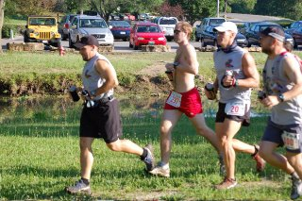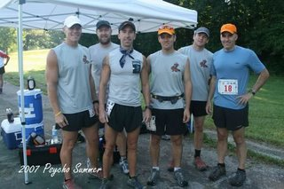
The Trail Nerds
The past week was a pretty good one. I was able to get in 82 miles of which 31 was during the Psycho Psummer Race at Wyco. Wednesday night we took the boys for football registration and equipment pickup. I hope they enjot it and stick with it,,,,$600.00 for them to play football plus fundraising!!! After we got home an ate they strapped on the pads and beat the crap out of each other until dark in the front yard. It is pretty funny watching an 8 and 5 year old in full pads taking turns knocking each other down for a few hours.

I had taken off Friday and we went out to the course to finish up marking the last few miles. Unfortunately we got the section which was still full of mud holes and my kids stepped in about every one while helping mark the course. After we finished up there we headed out to T-Rex and had lunch and then watched Transformers. The movie was great,,,,I am not sure who liked it more, me, Rick, John or the boys. We hung out at home that evening and ordered pizza.

Saturday morning Rick, John and I got to the race about 7:15. As soon as we parked Carey Smith pulled up next to us in the parking lot, he and his fellow slug Stephen made the trip from St. Louis for our little race. Once we got everything taken care of it was about time to start. I had 2 handhelds which I planned on draining before every aid station. My main goal for this race was to keep the system in balance to avoid cramping and stomach issues and to keep running as much as possible. I had a bandana to refill with ice at every aid station, I knew it would take time to refill constantly but I also know how important it is to keep from overheating.

Once Ben gave the instructions we were off. The pace seemed really quick the first mile. I knew everyone would slow quickly so I just hung back and waited for the 3 hills to move by some overzealous starters. By the third down hill I completely let it go. It is the first time I have ever lost control running down hill. I passed about 5 or six people here but I really couldn't see what was in front of me. Every step was jarring and I was just trying to feel the ground to stay on my feet. Luckily the people in front of me cleared the way or there could have been a pile up. After that I got in a decent groove and ran the entire 2nd loop with Carey. We talked most of the time which really made the first loop go by quickly. Dan Volk was also near us and joined in the conversation. We finished the first loop around 2:45 and got started on the 2nd. I knew the heat was going to start taking a toll and it soon followed. I slowed down a bit around mile 18, Carey and Dan started to pull away and I just decided to hang back and get through the down spot. So far everything was going well and I was steadily popping S caps and refilling with Succeed and Ice at every aid station.

By the time I got to the next water station I was pretty much all alone with no one in site. I was still feeling good and now taking 2 S-caps every 30 minutes. I was starting to get in a pretty good groove while goin down the single track along the ridge section until something caught my foot. I tried to catch myself but the momentum plus going downhill was too strong to overcome. I crashed on my shoulder and my water bottles went rolling down the hill. I looked down at my knee and it was bleeding pretty good, along with my shoulder which was pretty scraped up. It took a few minutes to gather myself and find my water bottles. I used one of the bottles to wash the cuts out and the other I saved for drinking. I was pretty shaken up but once I got moving the pain started to let up.
The last 7 miles I ran at a slow, steady pace and actually felt really good. I passed a few people the last 5 miles and crossed the line at 5:55. Overall the race went well, I ran with a good mindset and was able to stay cramp free. I ended up taking 24 S-caps over 31 miles and put down about 5 gallons of fluids. The temperature was 92 when I crossed the line. I really enjoyed myself at this race, Rick and I had a good time hanging out and talking to people for a few hours afterwards.
Congrats to Wynn Davis for tearing up the course....you rock. Thanks to all of the volunteers who were out in the nasty heat all day just to make sure we got home safe and sound. Carey, it was nice to spend some time chatting with you out on the trails. To all the nerds who busted your butts out there Saturday thanks for just being nerds.

